**Noah Mousseau**

**CSC 4330 Sec 001**

**HW3 UX/UI DroidCafe App Enhancement**

**Steps to Enhance:**

1. Navigate to the activity_order.xml file
2. Underneath the RadioGroup item, create a new item, <Button
3. Use the following attribute declarations: A screen shot of a computer code

   Description automatically generated
   1. In order for the android:text attribute to be correct, first label it “Date”, then extract the string to “date_button”
   2. The layout constraints constrain this new date button to be beneath the RadioGroup
4. Next, navigate to the OrderActivity.java file
5. Within the onCreate function, add the following code: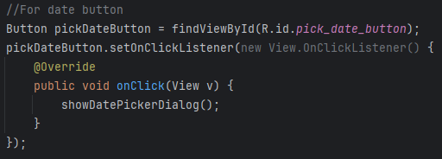
   1. Feel free to adjust the new View.OnClickListener to use lambda instead of the declaration it currently uses
   2. Be sure to import the required classes
6. Next, move down outside the onCreate function, and create the showDatePickerDialog function: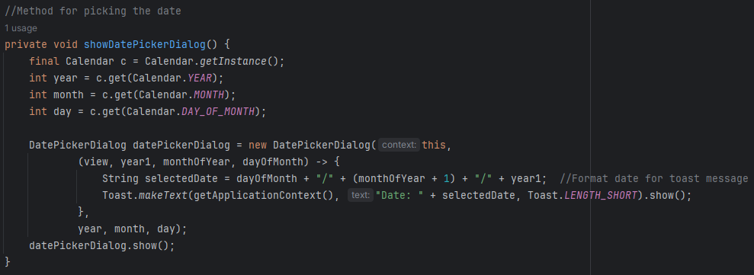
   1. Be sure to import all required classes
   2. This code uses the calendar class to generate an instance of Calendar, and use it to get the year, month, and day
   3. It then generates the Calendar dialog window, where the user can select a date, and press an “Ok” button
   4. Then, the program sends a toast with the date the user selected
7. This accomplishes the goal of adding a date button, and an interactive dialog where the user can select a date and see a toast of the date they selected appear